Part 1: Intro and CPU virtualization
Q. The two general roles of an operating system is to provide high level abstraction and manage resources. Elaborate what that means and why these roles are important.
What?
Operating systems provide:
- a fairly standardised abstraction between hardware and userspace software, that allows userspace software to be written with little concern for the hardware it is running on, and having access to a bunch of useful things like memory, files, screens, i/o etc.
- resource management and allocation to processes & threads. resources include files, memory, cpu runtime, etc.
i) high-level abstractions
why?
- more friendly to programmers
- provides common core for all applications
- hides details of hardware to make application code portable
ii) resource manager
why?
- divides resources amongst competing programs or users according to some system policy to ensure fairness and no starvation where possible.

Q. In contrast to MLFQ, Completely Fair Scheduler (CFS) in linux doesn't use any heuristics to identify interactive tasks rather it just makes sure every process gets a fair share of CPU within a set amount of time given the number of runnable processes on the CPU. Briefly state some key ideas by which CFS achieves this objective.
Q. Consider the following set of processes, with the length of the CPU burst time given in milliseconds. For practical purpose, processes may begin executing 1 ms after they arrive (i.e., a process arriving at time 5 could start executing at time 6). Any process arriving at time 0 is in the ready queue when the scheduler makes a decision about the first process to run.
Process | Burst | Priority | Arrival time
P1 | 5 | 4 | 0
P2 | 7 | 1 | 5
P3 | 6 | 3 | 5
P4 | 2 | 2 | 8
P5 | 4 | 2 | 10

Determine the schedule for each process using each of the following scheduling algorithms: (i) round-robin (RR) with time quantum = 1 ms, (ii) shortest time to completion first (STCF), and (iii) a non-preemptive priority scheme in which lower numbers indicate higher priority. To break ties between processes (same burst time/priority), use first-come, first-serve ordering. Please fill up the following table (St, End, TT denotes start time, end time and turnaround time respectively)
 | (i) RR |  |  | (ii) STCF |  |  | (iii) Priority
Proc | St | End | TT | St | End | TT | St | End | TT
P1 | 1 | 5 | 5 | 1 | 5 | 5 | 1 | 5 | 5
P2 | 6 | 24 | 19 | 18 | 24 | 19 | 6 | 12 | 7
P3 | 7 | 23 | 18 | 6 | 13 | 8 | 19 | 24 | 19
P4 | 10 | 14 | 6 | 9 | 10 | 2 | 13 | 14 | 6
P5 | 11 | 21 | 11 | 14 | 17 | 7 | 15 | 18 | 8

Part 2: Memory virtualization
- What happens when memory allocated for a heap (segment) runs out of space and needs to grow ? Explain.
- Assume a hybrid system employs two level paging, has a 32 bit virtual address space, and uses both 4KB and 4MB pages at the same time. The size of the page directory entry as well as page table entry is 4 bytes. The page directory has 1024 entries (4KB). The content of each page directory entry is given as
[valid bit | large bit | physical frame number (PFN)].
If the valid bit is set to 1 and the large bit set to 0, then PFN refers to the 4KB page of the inner page table. However, the valid bit is set to 1 and the large bit is set to 1, the PFN directly refers to a large page of size 4MB in the main memory. Assuming that for the first and last entries of the page directory, the valid and large bits are set to 1, and for the remaining entries, the valid bit is set to 1 but the large bit is set to 0. Calculate the total memory that the process can legally access in such a setting ? (Justify your answer, Writing final answer will not give you full marks)
- Consider a 64-bit system running an OS that uses hierarchical page tables to manage virtual memory. Assume that logical and physical pages are of size 4KB and each page table entry is 4 bytes in size.
(a) What is the maximum number of levels in the page table of a process, including both the outermost page directory and the innermost page tables?
(b) Indicate which bits of the virtual address are used to index into each of the levels of the page table.
(c) Calculate the maximum number of pages that may be required to store all the page table entries of a process across all levels of the page table.
Part 3: Concurrency
Q1 [6-7m]. Consider the classical “Sleeping-Barber” synchronization problem using two thread types, barber and customer, and a waiting room to hold customers:
- When the barber finishes with a current customer, he checks the waiting room. If a customer is waiting, he removes the customer from the waiting room and indicates he’s available to cut hair. Otherwise, the barber sleeps until a new customer arrives.
- When a customer arrives, he checks the barber’s status. If the barber is sleeping, the customer wakes the barber up. Otherwise, the customer enters the waiting room. If a seat is available, the customer takes it; otherwise, he leaves (without waiting)
There may be multiple barbers and customers, with up to N customers waiting in the waiting room. The solution requires three semaphores and a shared variable to track free seats in the waiting room, initialized as shown below. Write the pseudo code of barber and customer thread with appropriate comments and/or explanation of its working
semaphore barbers = 0; // # free barbers
semaphore customers = 0; // # waiting customers
semaphore mutex = 1; // Used if mutual exclusion needed
int freeSeats = N; // # free seats in waiting room

Ans:
void barber() {
while (true) { // Repeat barber process indefinitely
down(customers); // Try to acquire customer, sleeping // if there are none
down(mutex); // Must lock access to freeSeats
freeSeats++; // Indicate seat is free
up(barbers); // Let customer know barber’s available
up(mutex); // Release “lock”
cut_hair(); // Actual "work" of performing haircut
}
}
void customer() {
down(mutex); |  | // | Lock access to freeSeats
if (freeSeats > 0) | { |  | // Check if seat available
freeSeats--; |  | // | Take seat
up(customers); |  | // | Indicate customer is waiting
up(mutex); |  | // | Unlock “lock”
down(barbers); |  | // | Try to “acquire” barber
get_haircut(); |  | // | Actual "work" of getting haircut
]  else {  up(mutex); |  | // | Must release “lock” before leaving
}
}
Q2[5-6m]. A file is to be shared among different processes, each of which owns a unique number. The file can be accessed simultaneously by several threads, subject to the following constraint: the sum of the unique numbers owned by the threads (the unique number can be its ID for instance) currently accessing the file must be less than a defined constant MAX_N. Using condition variable to coordinate file access, write the pseudo code for access_file() and finish_access() called by the threads to request and finish file access respectively. Also mention the initialization of any variables.
Ans:
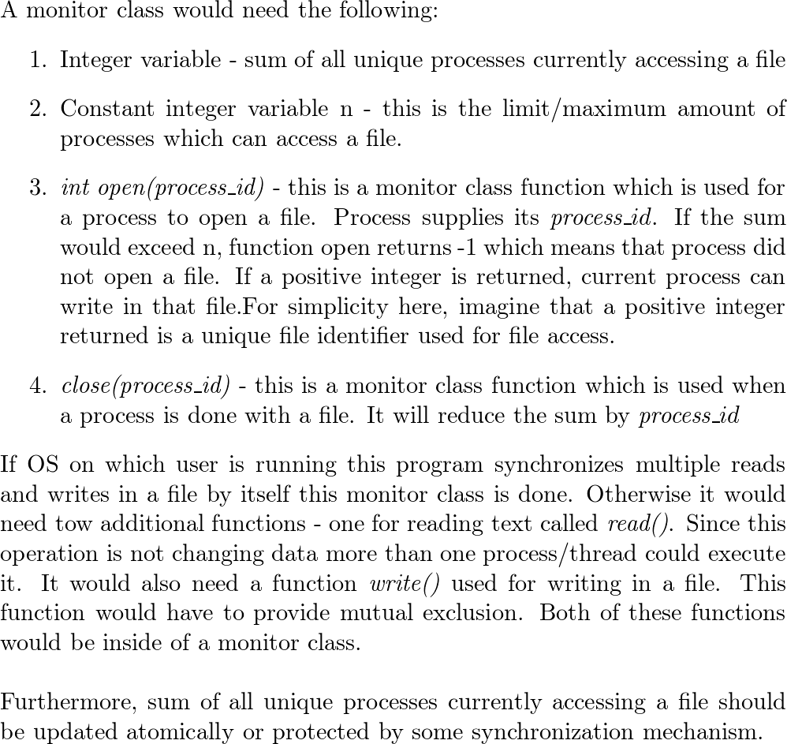
Q. [2-3m] You are running a program with three concurrent threads, each of which start execution by operating on two semaphores, S1 and S2, as shown below. Assume both semaphores are initialized to 0:
Thread 1 Thread 2 Thread 3
wait(&S1); wait(&S1); wait(&S2);
post(&S2); post(&S2); wait(&S2);
... ... post(&S1);
post (&S1); ...
Explain what is the bug here and show how you could rewrite the threads to remove the bug.
Since every thread starts by calling down on a semaphore that’s initialized to 0, the threads are guaranteed to deadlock. They’ll all be stuck waiting for each other to increment one of the semaphores.
Resolving this deadlock means changing the order of at least one of the threads. Either:
- Thread 1 & 2 must both call up(&S2) before calling down(&S1), or
- Thread 3 must complete both up(&S1) calls before calling down(&S2)

Q[3-4m]. Your system is currently running 3 processes: A, B, and C. Each process requests two types of resources: files and network connections. Assume the system can handle up to 5 open files and 5 network connections (abbreviated “conn.”) in total, across all processes.
Each process makes the resource requests shown in the table below, which lists total requested resources, initial state (resources the process is already using at this point), and a list of individual requests. Each individual request consists of a unique ID (A1 or B2, for example) and the resources requested (files, connections, or both). Each process only frees resources when it ends, which occurs after all its requests are complete.
 | Process A | Process B | Process C
Total requested resources | 4 files  3 connections | 5 files  5 connections | 5 files  3 connections
Initial state (already using) | 1 file | 2 connections | 1 file
Individual resource requests | - 2 files, 1 conn.  - 2 conn.  - 1 file | - 4 files  - 1 file, 1 conn.  - 2 conn. | - 3 conn.  - 2 files  - 2 files

Use the Banker’s Algorithm to find an order in which all resource requests can be satisfied and list that order in the space provided. You must show the total amount of each resource type used at each step of your solution. Requests from the same process must be in order (for example, A1 must be satisfied before A2), but requests from different processes may be in any order (A1 may be satisfied before or after B1).
Solution: This problem doesn’t require you to interleave requests from different threads—in fact, if you try to do so, you’ll get stuck—but it does impose a specific order between the three threads, because 2 files and 2 connections are in use when you start. Looking at the remaining resource requests for each thread:
- Thread A needs 3 more files and 3 more connections to finish.
- Thread B needs 5 more files and 3 more connections to finish.
- Thread C needs 4 more files and 3 more connections to finish
The threads must therefore run in the order A, C, B. Step-by-step solution to problem :
Initial state: 2 files, 2 connections used
1) A1 (total: 4 files, 3 connections)
2) A2 (total: 4 files, 5 connection)
3) A3 (total: 5 files, 5 connections)
- A completes (total used 1 file, 2 connections)
4) C1 (total: 1 file, 5 connections)
5) C2 (total: 3 files, 5 connections)
6) C3 (total: 5 files, 5 connections)
- C completes (no files, 2 connections used)
7) B1 (total: 4 files, 2 connections)
8) B2 (total: 5 files, 3 connections)
9) B3 (total: 5 files, 5 connections)
- B completes (no files or connections used)

Q. [4m] Consider the following attempt to implement software solution to two thread critical section problem. In this, when one thread finds that the other thread also intends to enter its critical section, it sets its own intendToEnter flag to false and waits for the other thread to exit its critical section.
______T0 ______________T1 _____________
while (true) { while (true) {
intendToEnter0 = true; (1) intendToEnter1 = true; (1)
while (intendToEnter1) { (2) while (intendToEnter0) { (2)
intendToEnter0 = false; (3) intendToEnter1 = false; (3)
while(intendToEnter1) {;} (4) while(intendToEnter0) {;} (4)
intendToEnter0 = true; (5) intendToEnter1 = true; (5)
} }
critical section (6) critical section (6)
intendToEnter0 = false; (7) intendToEnter1 = false; (7)
non-critical section (8) non-critical section (8)
} }

Explain whether this one is a correct solution. If not, explain which of the requirement is not satisfied.

Ans: This solution ensures that when both intendToEnter0 and intendToEnter1 are true, only one of T0 and T1 is allowed to enter its critical section. Thus, the mutual exclusion requirement is satisfied.
There is a problem with this solution, as illustrated by the following execution sequence:
T0 T1 Comments
- intendToEnter0 is set to true
- T0 exits the first while-loop in the entry section
- T0 enters its critical section; intendToEnter0 is true context switch
(1) intendToEnter1 is set to true
(2)-(3) intendToEnter1 is set to false
(4) T1 enters the second while-loop in the entry section
context switch
- intendToEnter0 is set to false
- T0 executes its non-critical section
- intendToEnter0 is set to true
- T0 exits the first while-loop in the entry section
- T0 enters its critical section; intendToEnter0 is true context switch
(4) T1 is still waiting for intendToEnter0 to be false context switch

... repeat infinitely
In this execution sequence, T0 enters its critical section infinitely often and T1 waits forever to enter its critical section.Thus, this solution does not guarantee bounded waiting.

